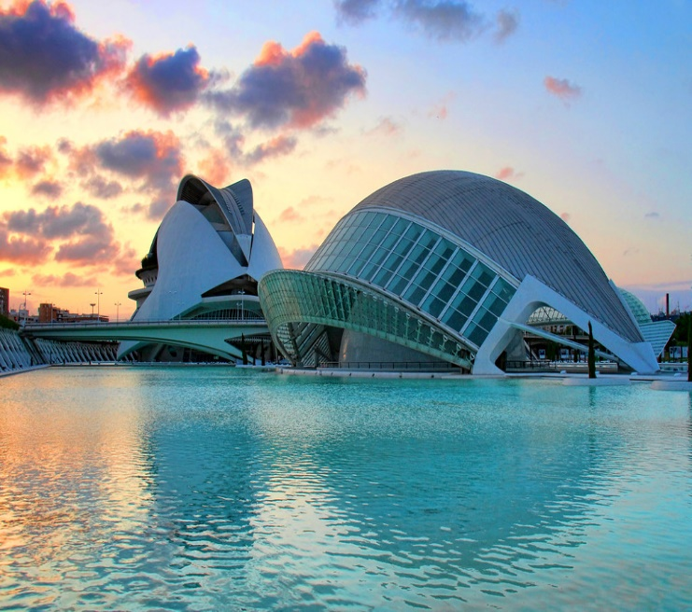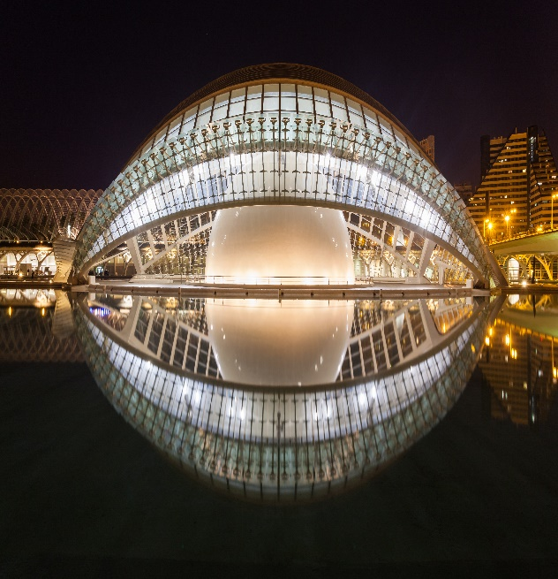

# City of Arts and Sciences

The **City of Arts and Sciences** ([Valencian](https://en.wikipedia.org/wiki/Valencian_language): ***Ciutat de les Arts i les Ciències***, [Spanish](https://en.wikipedia.org/wiki/Spanish_language): ***Ciudad de las Artes y las Ciencias***)[[a]](https://en.wikipedia.org/wiki/City_of_Arts_and_Sciences#cite_note-1) is a cultural and architectural complex in the city of [Valencia](https://en.wikipedia.org/wiki/Valencia,_Spain), [Spain](https://en.wikipedia.org/wiki/Spain). It is the most important modern tourist destination in the city of Valencia and one of the [12 Treasures of Spain](https://en.wikipedia.org/wiki/12_Treasures_of_Spain).

The City of Arts and Sciences is situated at the southeast end of the former riverbed of the river [Turia](https://en.wikipedia.org/wiki/Turia_(river)" \o "Turia (river)), which was drained and rerouted after a catastrophic [flood in 1957](https://en.wikipedia.org/wiki/1957_Valencia_flood). The old riverbed was turned into a picturesque sunken park.

Designed by [Santiago Calatrava](https://en.wikipedia.org/wiki/Santiago_Calatrava) and [Félix Candela](https://en.wikipedia.org/wiki/F%C3%A9lix_Candela), the project began the first stages of construction in July 1996, and was inaugurated on 16 April 1998 with the opening of L'Hemisfèric. The last major component of the City of Arts and Sciences, [Palau de les Arts Reina Sofía](https://en.wikipedia.org/wiki/Palau_de_les_Arts_Reina_Sof%C3%ADa), was inaugurated on 9 October 2005, [Valencian Community Day](https://en.wikipedia.org/wiki/Valencian_Community_Day). The most recent building in the complex, L'Àgora, was opened in 2009.[[1]](https://en.wikipedia.org/wiki/City_of_Arts_and_Sciences#cite_note-ABC_2009-2)

Originally budgeted at €300 million in 1991 for three structures, it has expanded about three times the initial expected cost.

## **History**

In 1989, the president of the [Valencian Autonomous Government](https://en.wikipedia.org/wiki/Valencian_Community#Government), [Joan Lerma](https://en.wikipedia.org/wiki/Joan_Lerma), after a visit to the new [Cité des Sciences et de l'Industrie](https://en.wikipedia.org/wiki/Cit%C3%A9_des_Sciences_et_de_l%27Industrie" \o "Cité des Sciences et de l'Industrie) in Paris, and through the general director of planning and studies of the Presidency of the [Generalitat Valenciana](https://en.wikipedia.org/wiki/Generalitat_Valenciana" \o "Generalitat Valenciana), José María Bernabé, officially commissioned the scientist Antonio Ten Ros to draft a first proposal for a City of Science and Technology for Valencia.[[6]](https://en.wikipedia.org/wiki/City_of_Arts_and_Sciences#cite_note-osset_1989-7)

Ten Ros drew up a first draft, entitled "Vilanova, A City of Science for Valencia", which was officially presented to the Generalitat in May 1989. After that, he was formally commissioned in 1990 to direct the creation of a general draft amounting to 92,650,000 pesetas (556,000 euros), to be managed by the [University of Valencia](https://en.wikipedia.org/wiki/University_of_Valencia). Antonio Ten Ros assembled a team of 56 scientists, museologists and designers including Professor José María López Piñero as responsible for the space "A walk through history". Ten Ros presented the draft in 32 volumes to President Lerma in the Palace of the Generalitat on 21 December 1991.[[6]](https://en.wikipedia.org/wiki/City_of_Arts_and_Sciences#cite_note-osset_1989-7)

The "City of Science and Communications" was the name that the autonomous government gave to the initiative, and plans included a 370 m high [communications tower](https://en.wikipedia.org/wiki/Communications_tower), which would have been the third highest one in the world at that time; a [planetarium](https://en.wikipedia.org/wiki/Planetarium); and a museum of science. The total price of the works was estimated to be about 25,000 million [pesetas](https://en.wikipedia.org/wiki/Spanish_peseta).

In May 1991, the council approved the transfer of lands. Four months later the project plan with three structures (communications tower, planetarium, and a science museum) was presented, designed by [Santiago Calatrava](https://en.wikipedia.org/wiki/Santiago_Calatrava).[[7]](https://en.wikipedia.org/wiki/City_of_Arts_and_Sciences#cite_note-osset_1991-8)

The team that had designed the museum did not see eye to eye with the form in which Santiago Calatrava conceived the building, and a couple of changes were made. Preliminary site work began by the end of 1994.[[7]](https://en.wikipedia.org/wiki/City_of_Arts_and_Sciences#cite_note-osset_1991-8)

The project was not without controversy. The Conservative [Popular Party](https://en.wikipedia.org/wiki/People%27s_Party_(Spain)) saw in the City of Science a "work of the pharaohs" that would serve only to swell the ego of the [Socialists](https://en.wikipedia.org/wiki/Spanish_Socialist_Workers%27_Party), who were the driving forces behind the initiative.[[8]](https://en.wikipedia.org/wiki/City_of_Arts_and_Sciences#cite_note-El_Pais_2012-9)